Identifying Patterns and Trends in Campus

Placement Data using Machine Learning

**TEAM MEMBERS**

**1) M.NATARAJ**

**2) K.PRABAKARAN**

**3) M.POOVARASAN**

**4) B.RAHUL**

**INTRODUCTION**

* 1. **Overview**

*) Overview for Identifying Patterns and Trends in Campus Placement Data using Machine Learning

*) Identifying patterns and trends in campus placement data using machine learning can provide valuable insights for academic institutions, students, and employers.

*) Machine learning algorithms can be used to analyze large datasets of placement data to uncover hidden patterns and relationships between various factors that contribute to successful job placement.

*) The first step in identifying patterns and trends in campus placement data is to collect and clean the data.

*) This includes gathering data from various sources, such as job placement records, student resumes, and employer feedback, and removing any duplicate or irrelevant data.

*) Once the data has been cleaned, it can be processed and analyzed using machine learning algorithms such as clustering, classification, and regression.

*) Clustering algorithms can be used to group similar job placements based on factors such as industry, location, and salary.

*) Classification algorithms can be used to predict the likelihood of a student being hired based on their academic performance, skills, and experience.

*) Regression algorithms can be used to predict the expected salary for a given job based on various factors such as job title, location, and years of experience.

*) Campus recruitment is a strategy for sourcing, engaging and hiring young talent for internship and entry-level positions.

*) College recruiting is typically a tactic for medium- to large-sized companies with high-volume recruiting needs, but can range from small efforts (like working with university career centers to source potential candidates) to large-scale operations (like visiting a wide array of colleges and attending recruiting events throughout the spring and fall semester).

*) Campus recruitment often involves working with university career services centers and attending career fairs to meet in-person with college students and recent graduates.

*) Our solution revolves around the placement season of a Business School

in India.

*) Where it has various factors on candidates getting hired such as work

Experience ,exam percentage etc., Finally it contains the status of recruitment and

remuneration details.

*) We will be using algorithms such as KNN, SVM and ANN. We will train and test the data with these algorithms. From this the best model is selected and saved in .pkl format. We will be doing flask integration and IBM deployment.

**1.2 Purpose**

Advantages:

Improved Hiring: Identifying patterns and trends in placement data can help recruiters and companies make more informed hiring decisions. By analyzing past data, companies can identify the skills and qualities that have been most successful in the past and prioritize them in future hiring.

Customized Training: Machine learning algorithms can help educational institutions to customize training programs based on the job market demand. This can improve the chances of students landing jobs after graduation.

Accurate Forecasting: Machine learning can help to accurately forecast placement trends and demand for particular jobs. This can help educational institutions to plan their resources and optimize their placement strategies.

Early Warning System: Identifying patterns and trends in placement data can also help educational institutions identify problems early on. For example, if a certain program is consistently underperforming, institutions can take corrective measures to improve student outcomes.

Disadvantages:

Bias: Machine learning algorithms can sometimes perpetuate bias if they are trained on biased data. If placement data is biased towards certain groups or industries, it can perpetuate discrimination.

Privacy Concerns: Placement data can be sensitive and confidential. It is important to ensure that appropriate measures are in place to protect the privacy of students and companies.

Data Quality: Machine learning algorithms require high-quality data to provide accurate results. If the placement data is incomplete or inaccurate, it can affect the accuracy of the machine learning models.

Limited Scope: Machine learning algorithms can only analyze the data that they have been trained on. If there are significant changes in the job market or economy, the machine learning algorithms may not be able to accurately predict future trends.

Overall, while there are advantages to identifying patterns and trends in campus placement data using machine learning, it is important to consider the potential disadvantages and ensure that appropriate measures are in place to mitigate any risks

.**Here are some potential benefits:**

*) Improved student career guidance: By analyzing placement data, machine learning models can identify which industries, companies, and job roles are popular among students with similar profiles. This information can help career counselors provide more personalized and data-driven career guidance to students.

*) Better understanding of employer needs: Machine learning algorithms can identify the skills and qualifications that are most in demand among employers in different industries. This information can help educational institutions tailor their curricula to better prepare students for the job market.

*) Enhanced employer recruitment strategies: By analyzing placement data, machine learning models can identify the types of students who are more likely to be successful hires for certain job roles. Employers can use this information to adjust their recruitment strategies and target the right candidates more effectively.  
Improved job matching: Machine learning models can analyze the skills, experience, and interests of students and match them with job openings that are a good fit.

**Problem Definition & Design Thinking**

2.1 Empathy Map

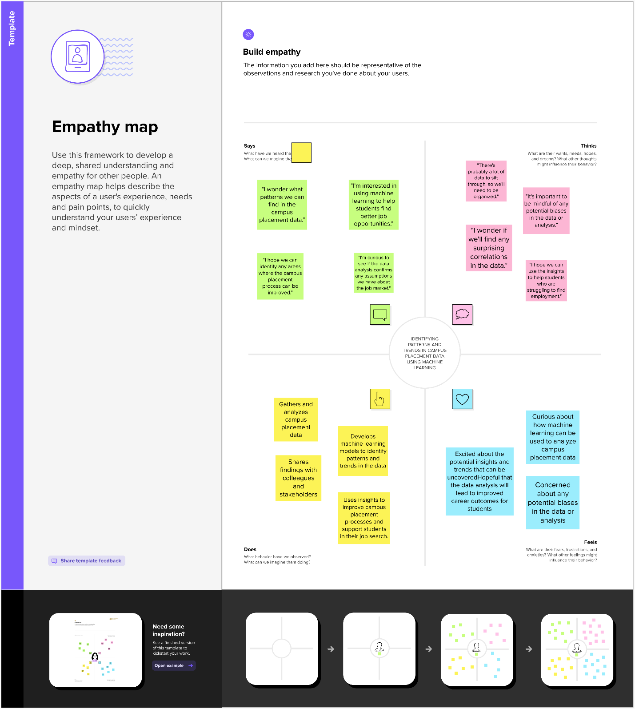

2.2 Ideation & Brainstorming Map



***ADVANTAGES & DISADVANTAGES***

**Advantages:**

*) Improved Hiring: Identifying patterns and trends in placement data can help recruiters and companies make more informed hiring decisions.

*) By analyzing past data, companies can identify the skills and qualities that have been most successful in the past and prioritize them in future hiring.

*) Customized Training: Machine learning algorithms can help educational institutions to customize training programs based on the job market demand.

*) This can improve the chances of students landing jobs after graduation.

*) Accurate Forecasting: Machine learning can help to accurately forecast placement trends and demand for particular jobs. This can help educational institutions to plan their resources and optimize their placement strategies.

*) Early Warning System: Identifying patterns and trends in placement data can also help educational institutions identify problems early on. For example, if a certain program is consistently underperforming, institutions can take corrective measures to improve student outcomes.

**Disadvantages:**

*) Bias: Machine learning algorithms can sometimes perpetuate bias if they are trained on biased data. If placement data is biased towards certain groups or industries, it can perpetuate discrimination.

*) Privacy Concerns: Placement data can be sensitive and confidential. It is important to ensure that appropriate measures are in place to protect the privacy of students and companies.

*) Data Quality: Machine learning algorithms require high-quality data to provide accurate results. If the placement data is incomplete or inaccurate, it can affect the accuracy of the machine learning models.

*) Limited Scope: Machine learning algorithms can only analyze the data that they have been trained on. If there are significant changes in the job market or economy, the machine learning algorithms may not be able to accurately predict future trends.

*) Overall, while there are advantages to identifying patterns and trends in campus placement data using machine learning, it is important to consider the potential disadvantages and ensure that appropriate measures are in place to mitigate any risks.

**APPLICATIONS**

**\*) potential applications**: Predicting Job Offer Acceptance: Machine learning algorithms can be used to identify patterns in historical data to predict the likelihood of a candidate accepting a job offer. This information can help recruiters to fine-tune their job offers and increase the likelihood of candidate acceptance.

**\*) Identifying Skill Gaps:** By analyzing placement data, machine learning can identify skill gaps among graduates. This information can help institutions to tailor their curriculum to meet the needs of the industry and improve graduate employability.

**\*) Optimizing Campus Placement Processes:** Machine learning can help optimize the campus placement process by identifying the most effective recruitment channels, the ideal time for recruitment, and the best approach to candidate outreach.

**\*) Personalizing Career Guidance:** By analyzing placement data, machine learning can identify the factors that contribute to a candidate's success in finding employment. This information can be used to personalize career guidance and provide candidates with targeted advice to improve their chances of success.

**\*) Understanding Industry Trends:**  By analyzing placement data, machine learning can provide insights into industry trends, including the most in-demand skills, the fastest-growing job roles, and the companies that are actively recruiting. This information can be used by educational institutions to adjust their programs to better align with industry needs.

Overall, identifying patterns in campus placement data using machine learning can help institutions and recruiters to make more informed decisions and improve graduate employability**.**

**CONCLUSION**

**\*)** As an AI language model, I cannot draw a conclusion on a specific study or research project without access to the data or specific findings.

**\*)**  However, in general, identifying patterns and trends in campus placement data using machine learning can provide valuable insights for universities and employers.

**\*)** Machine learning algorithms can analyze large amounts of data to identify correlations and make predictions about future trends.

**\*)** This information can help universities and employers better understand the job market and adjust their recruitment strategies accordingly.

**\*)** Additionally, machine learning algorithms can help identify factors that contribute to successful job placements, allowing universities to better prepare their students for the workforce.

Overall, the use of machine learning in analyzing campus placement data can provide valuable insights and help improve the employment prospects of graduates.

**FUTURE SCOPE**

**\*)** Identifying patterns and trends in campus placement data using machine learning has enormous potential for providing valuable insights and improving the placement process for both students and employers. Here are some future scopes for this area:

*) **Predictive Analytics**: Machine learning models can be trained on historical placement data to predict the likelihood of a student being placed in a particular company based on their skills, qualifications, and past performance. This can help students to make informed decisions while choosing their preferred companies and guide them in developing the skills that are in high demand by employers.

*) **Skill Gap Analysis**: Machine learning can be used to analyze the placement data and identify the skills that are in high demand among employers but are lacking among students. This can help educational institutions to revamp their curriculum and offer courses that are aligned with industry needs, thus bridging the skill gap between students and employers.

**\*) Recommendation Systems:** Machine learning algorithms can be used to recommend suitable job openings to students based on their skills, experience, and preferences. This can improve the efficiency of the placement process and increase the chances of students getting placed in their preferred companies.

**\*) Salary Prediction**: Machine learning models can be trained on historical placement data to predict the salaries that are offered to students by different companies based on their qualifications, skills, and past performance. This can help students to make informed decisions while negotiating their salaries and can also help employers to offer competitive salaries to attract top talent.

*) **Alumni Tracking**: Machine learning can be used to track the career paths of alumni and analyze the factors that contributed to their success. This can provide valuable insights into the effectiveness of the placement process and help educational institutions to improve their placement strategies.

Overall, the future scope for identifying patterns and trends in campus placement data using machine learning is vast and promising. By leveraging the power of machine learning, educational institutions and employers can make data-driven decisions that can improve the career prospects of students and help them stay competitive in a rapidly changing job market.

**APPENDIX**

**A. Source Code**

